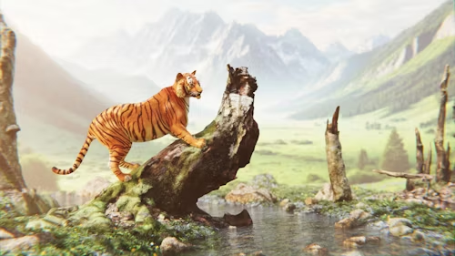

Nature Painting
Rs: 7,599
A beautiful piece of art that will enhance the grace of your home.

Key Features:
- Amazing Design
- Attractive Art
- Beautiful Color Palette
- Hand-Painted on High-Quality Canvas
- Perfect for Home and Office Decor

